**Week 5 – Final Project**

Ben Merritt

The University of Arizona Global Campus

CPT 307: Data Structures & Algorithms

Dr. Tina Tian

September 5, 2022

**Week 5 –** **Calculate ROI Program**

The Calculate ROI program allows the user to enter the number of equipment items they wish to enter along with the Gain and cost of each item. The program CalculateROI.java imports Collections, which contains sorting and comparing algorithms, as shown in Figure 5, the hierarchy of Collections (GeekforGeeks, 2022). Linklist is imported to create the linked list to hold the Equipment items and cost and gains. Scanner is imported to receive input from the user by a keyboard. The main program starts by creating a linked list called gaincostList inside the class GainCostEquipment. The first while loop is used as a menu loop with the numcount variable set to close the program if “-1” is entered. String name is used to get the Equipment name. The variables gain and cost are used to get the cost and gain from using Scanner input. Count is used in the second while loop inside the first menu while loop to complete the entry of Equipment with cost and gain for “numcount” loops. The variable gce holds each item's name, gain, and cost. The functions inside the class GainCostEquipment calculate the ROI with gce.calculateROI() for each item, and then they are added to the list by gaincostList.add(gce). Each loop is counted, and when the numcount is less than count, the list is sorted best to worst by Collections.sort(gaincostList). A print statement with a for loop Iterates the sorted list to display the final results.

The GainCostEquipment class has functions to get items and set items from the list to organize and keep gain and cost with the correct equipment. The function calculateROI() calculates each equipments ROI by taking the gain subtract cost, and dividing that total by cost. The ROI for each item is set to its equipment in the list. The get function returns ROI, cost, and gain for each item. The toString() function sets the display format for each item and result. The compareTo function or method compares each item's ROI on the list and returns the largest to least ROI sorted Equipment. The program returns the correct sorted results. Also, if another item is added to the list, then the sort function will resort the list and display the new results. The program can be ended by typing “-1” or displayed by “0”.

The input used for this program:

CISCO 2900 Series Router C2921-VSEC/K9 Integrated Services Router

Gain $1200 Cost $3965.99

Ubiquiti ERPOE-5 EdgeRouter PoE Advanced 5-Port Router

Gain $1073 Cost $800

Adtran 4243908F1 Network Equipment

Gain $1150 Cost $1973.99

Orbi 960 Series Quad-Band WiFi 6E Mesh System 10.8Gbps Router

Gain $2195.99 Cost $1499.99

**Figure 1**. The output of the Calculate ROI Program part one.

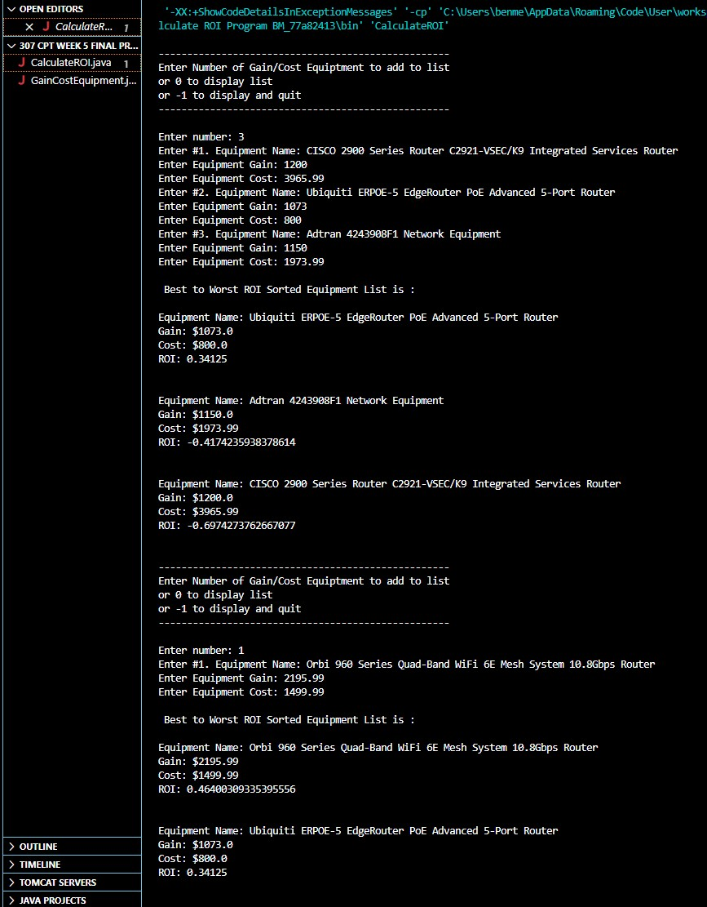

**Figure 2.** The output of the Calculate ROI Program part two.

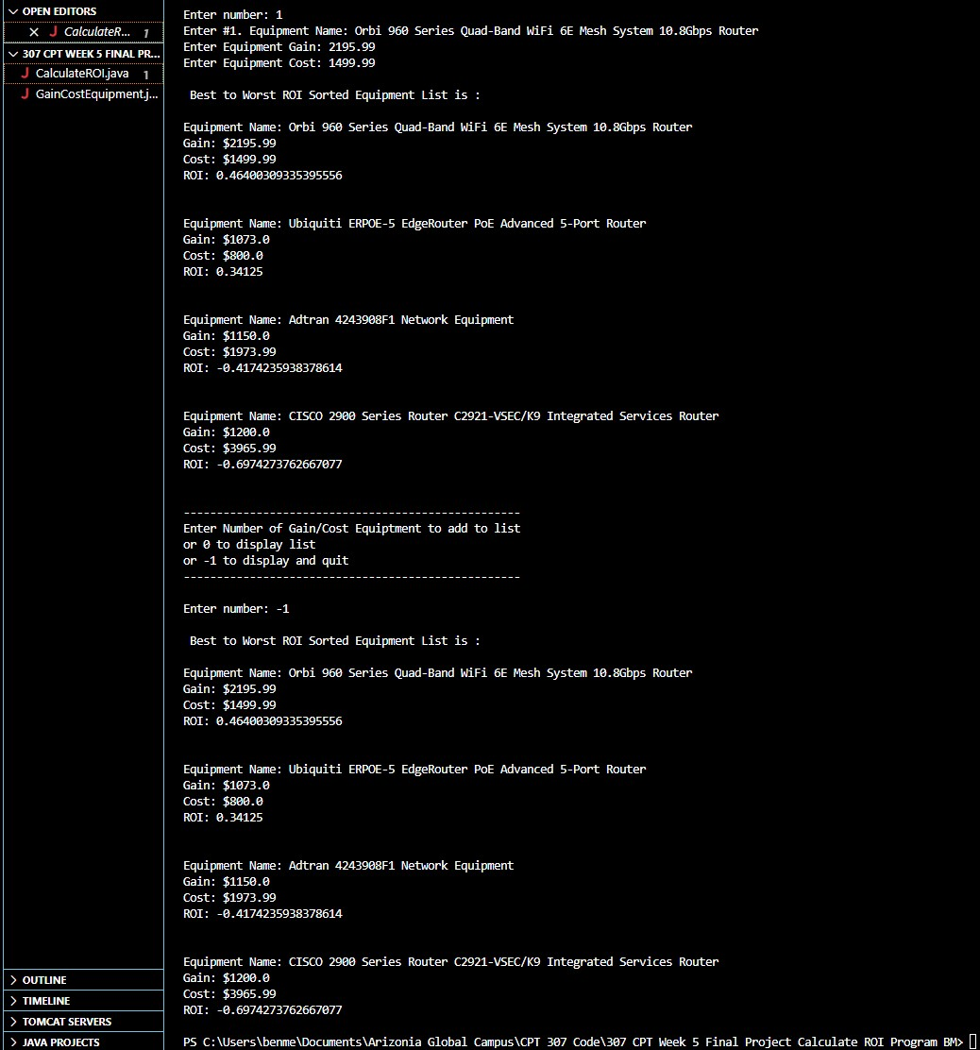

**Figure 3.** Code snapshot of the Calculate ROI Program part one.

**Figure 4.** Code snapshot of the Calculate ROI Program part two.

**Figure 5.** https://www.geeksforgeeks.org/collections-in-java-2/.

CalculateROI.java and GainCostEquipment.java Source code embedded document below:



References

GeeksforGeeks. (24 August 2022). Collections in Java Retrieved from https://www.geeksforgeeks.org/collections-in-java-2/